Assignment # 01



Fall 2024

**CSE-411 Intro to Game Development**

Submitted by: MUHAMMAD SADEEQ

Registration No.: 21PWCSE2028

Section: C

“On my honor, as a student of the University of Engineering and Technology, I have neither given nor received unauthorized assistance on this academic work”

Submitted to:

Engr. Abdullah Hamid

(19 Oct 2024)

Department of Computer systems engineering

University of Engineering and Technology, Peshawar

**Step 1:** First, I went to the Unity Asset store in my Browser

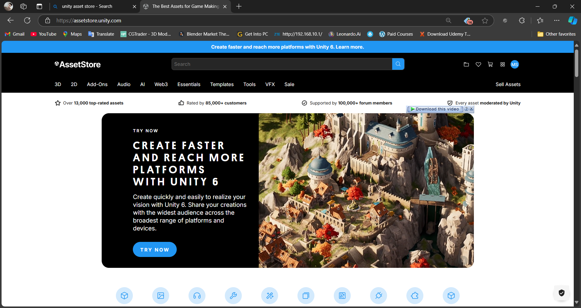

**Step 2:** I choose a Free Asset named “FREE Cartoon Pack – Buildings” and added it to my assets

**Step 3:** Then I click on the “Open in Unity” Button

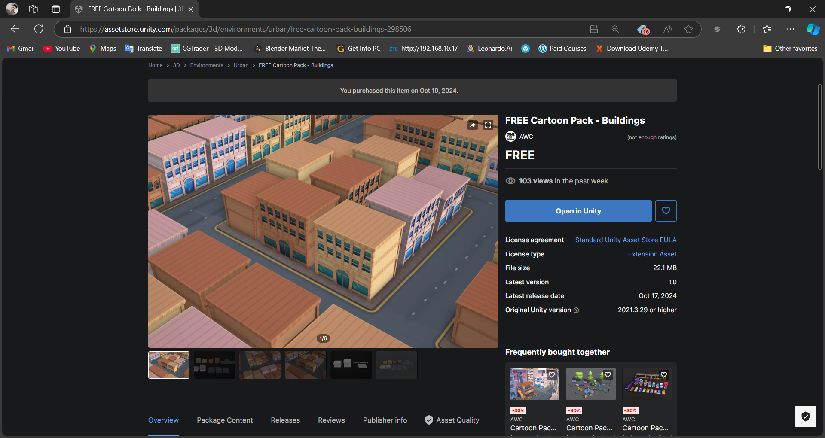

**Step 4:** Inside Unity my Package Manager Opened then I click on the download button the selected asset downloaded

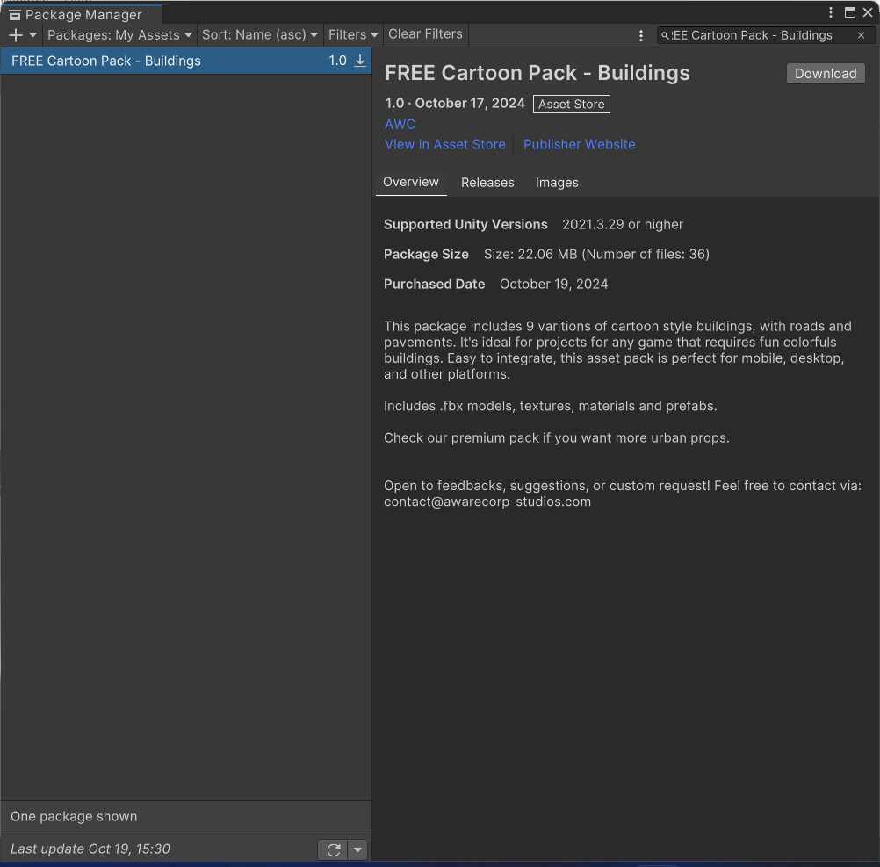

**Step 4:** When the asset downloaded, it shows import button I click on the import button another panel opened asking me what things I want to import from the asset.

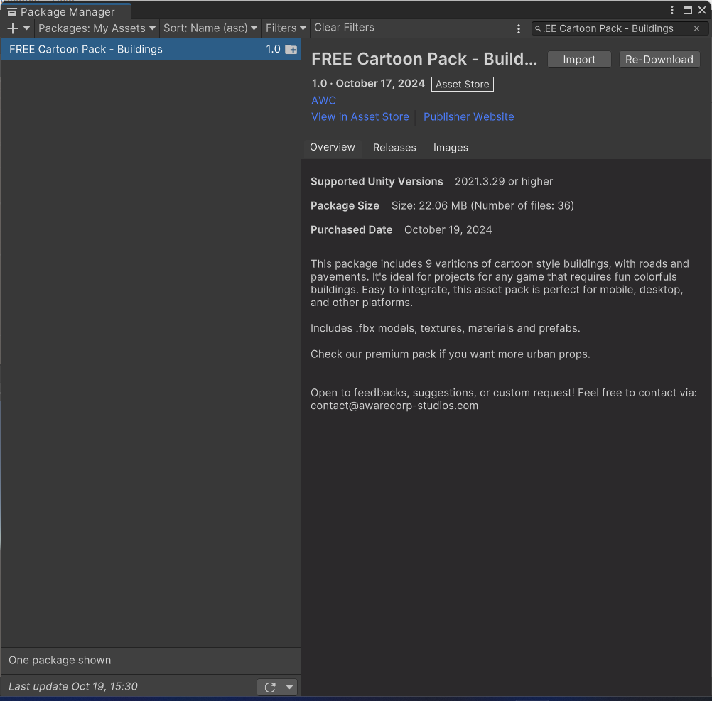

**Step 5:** Then click on import again and all the things in the asset imported to my unity project

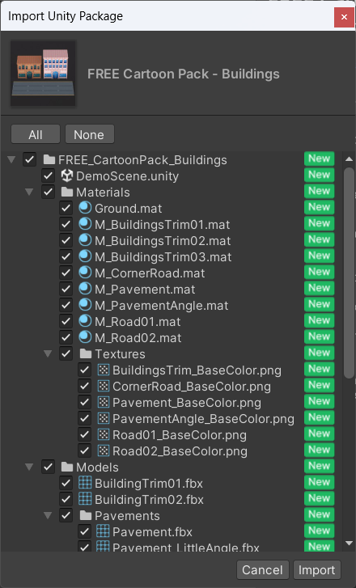

**Step 6:** A new folder created with the name of the imported package I opened it and went to the prefab folder in it and import some prefab objects and set it in my scene

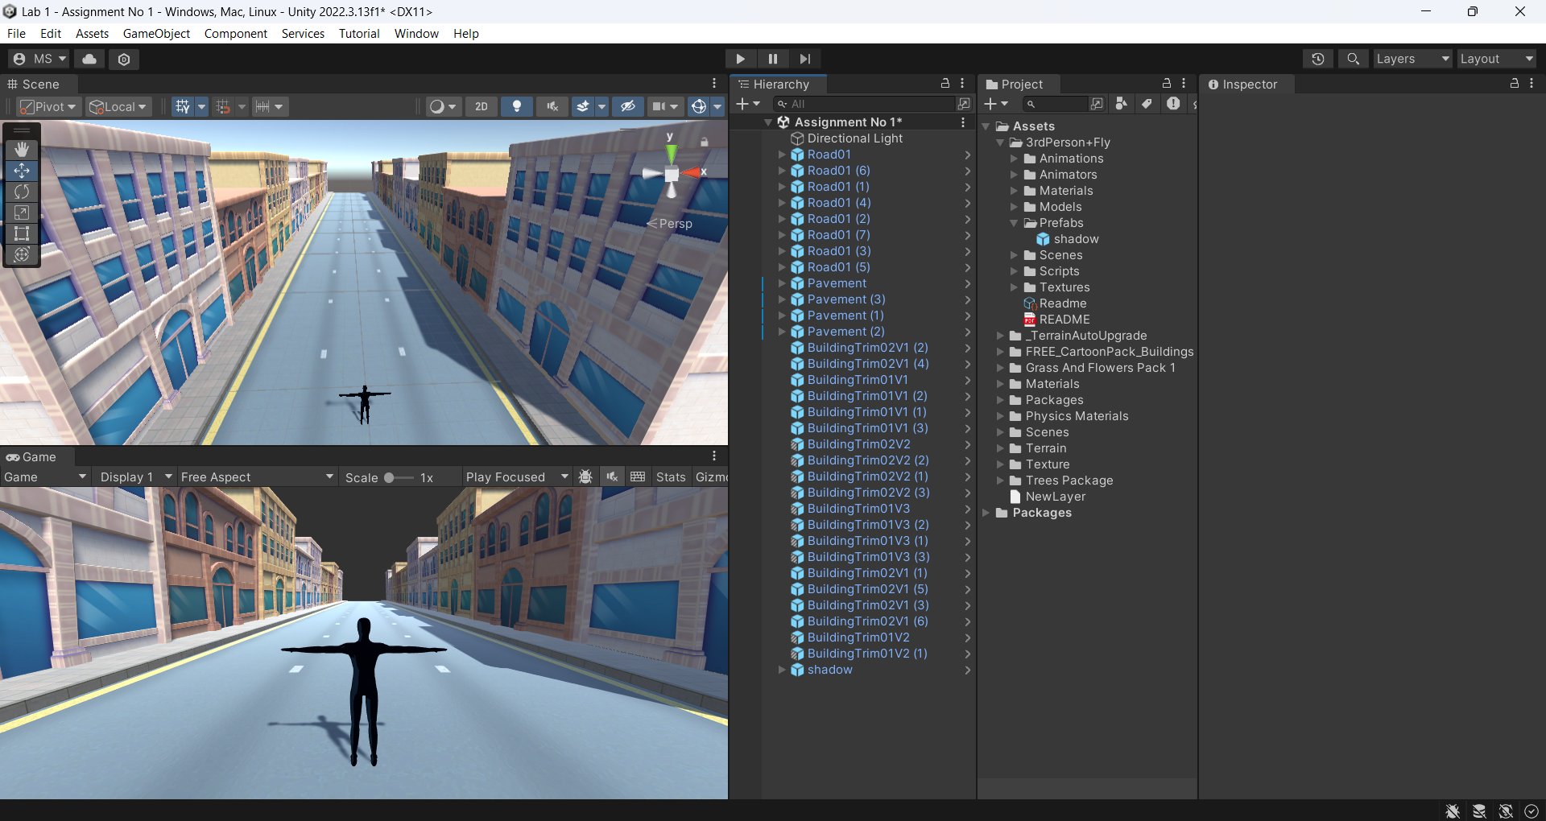

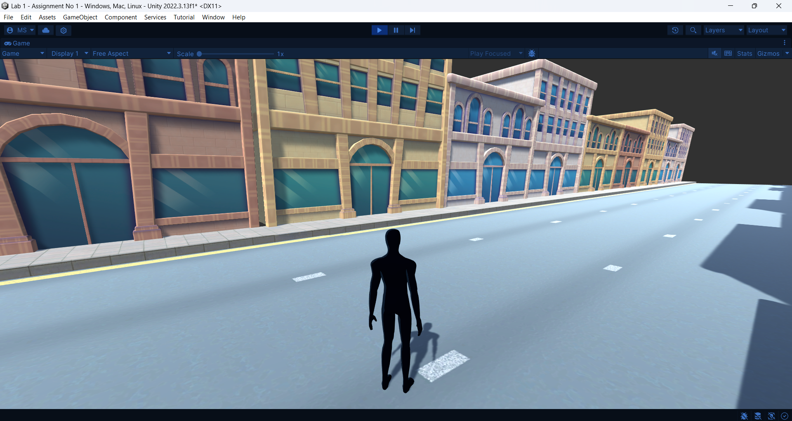

**Step 7:** In the End, I added a third person character in the scene to Play and Enjoy the Scene